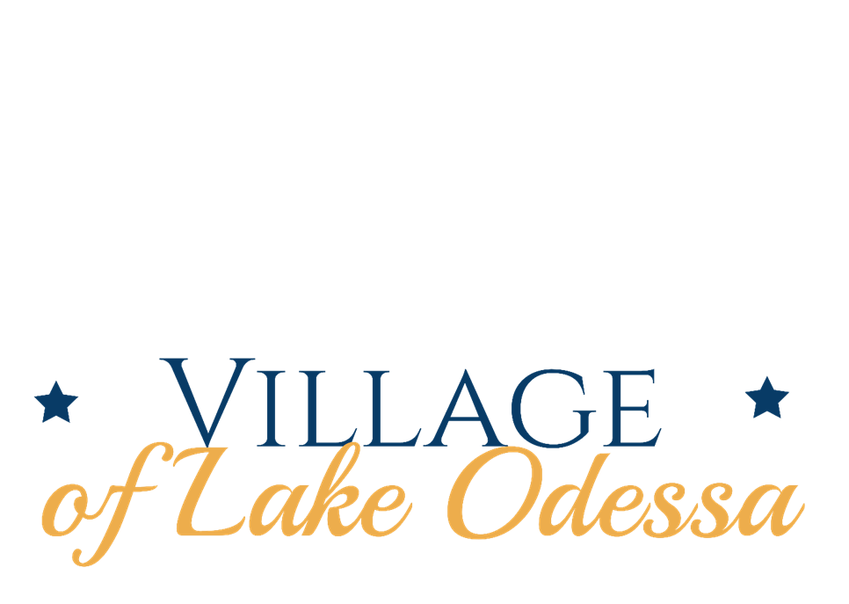

FISCAL YEAR 2024-2025 ADOPTED BUDGET

March 1, 2024 – February 28, 2025

Table of Contents

**Annual Budget Development Overview3**

Fund Summaries3

**Village Manager’s Message…………………………………………………………………………………………………………………4**

**Organization Chart6**

**Village Council…………………………………………………………………………………………………………………………………….7**

**Village Staff………………………………………………………………………………………………………………………………………. 8**

**Background / General Information……………………………………………………………………………………………………. 9**

**Capital Improvements Plan……………………………………………………………………………………………………………… 11**

**General Fund ………………………………………………………………………………………………………………………………….. 13**

Revenues13  
Appropriations………………………………………………………………………………………………………………………………… 14

Governing Body14  
Manager’s Department………………………………………………………………………………………………………………….15  
Page Building…………………………………………………………………………………………………………………………………15  
Police Department……………………………………………………………………………………………………………………….. 16  
Department of Public Works………………………………………………………………………………………………………… 17  
Parks and Recreation……………………………………………………………………………………………………………………. 18  
Utilities, Zoning, and Economic Development………………………………………………………………………………. 18

**General Fund Overview…………………………………………………………………………………………………………………….19**

**Major Street Fund…………………………………………………………………………………………………………………………….20**

**Local Street Fund………………………………………………………………………………………………………………………………21**

**Water Fund……………………………………………………………………………………………………………………………………….22**

**General Highway Fund………………………………………………………………………………………………………………………24**

**Downtown Development Authority………………………………………………………………………………………………….25**

**Arts Commission……………………………………………………………………………………………………………………………….26**

**Supplemental Information……………………………………………………………………………………………………………… 27**



ANNUAL BUDGET DEVELOPMENT OVERVIEW

Welcome to the Village of Lake Odessa’s budget document for Fiscal Year 2024-2025, which begins March 1, 2024 and continues through February 28, 2025. Guided by the policies and priorities of the Village Council, the budget is a vital policy document used throughout the year to implement and guide administration and staff towards municipal goals and objectives. The budget is approved annually by the Village Council in compliance with the General Law Village Act and includes detailed information about revenues and expenditures for the upcoming fiscal year. The revenues and expenditures are broken down by the various operating, enterprise and special funds that comprise the total spending plan.

FUND SUMMARIES

The budget is divided into eight separate funds with specific functions. The Village’s funds include:

* The **General Fund** is the most comprehensive operating fund of the Village. It accounts for the resources to fund Public Safety (police services), most operational and maintenance aspects of Public Works (including streets, storm sewers, tree maintenance, parks) and other general administration activities including legal support, financial management, communications and day-to-day administration. There is also a limited amount of capital expenditures that are funded through General Fund revenues and/or reserves.
* The **Water Fund** is an enterprise fund that provides resources for the operation and maintenance of the Village’s water production and distribution divisions. The Water Fund is designed to be a self-sustaining function that is funded entirely by user charges.
* The **Major Street Fund** is funded by revenues provided by the Michigan Transportation Fund (MTF) through Act 51. The Michigan Department of Transportation (MDOT) uses allocation factors to distribute MTF revenue to cities and villages. The distribution is based on population (as of the latest U.S. Census) and road miles. The fund encompasses the maintenance for all major streets in the village (approximately 4 miles). Through the General Appropriations Act, the Village Council can approve transfers of up to 50% of Act 51 Major Street money to the Local Street Fund.
* The **Local Street Fund** is also funded by revenues provided by the MTF through Act 51 using allocation factors set by MDOT. The Local Street Fund supports the maintenance of all local streets in the village (approximately 8 miles).
* The **General Highway Fund** is an operating fund that is supported by a millage dedicated to the construction, operation and maintenance of road activities in the village. The fund acts as a construction in progress account where grant monies run through and also funds a portion of bond payments for financed road projects. Road construction and sidewalk maintenance activities are funded through the General Highway fund.
* Component Unit funds include the **Downtown Development Authority** and **Arts Commission** funds.





**February 19, 2024**  
  
  
To the Lake Odessa Village Council,   
  
Attached for your review is the proposed Fiscal Year 2024-2025 budget for the Village of Lake Odessa which provides forecasted revenues and proposed expenditures for the fiscal year which begins March 1, 2024 and concludes February 28, 2025. The Village Council reviewed a draft of this budget in a workshop session held on February 5, 2024.

The budget being presented to you is one that is developed through the hard work and diligence of Village staff. This budget balances the needs for everyday services provided to the community as well as infrastructure improvements that are intended to increase/ maintain the health, safety, and welfare for the residents of the Village of Lake Odessa.

It should be noted that municipal budgets are living documents and should be considered as a guide to the efficient operation of the Village during the fiscal year. Equipment can break down, emergencies occur, opportunities for upgrades are found, and unexpected developments within a community can shift priorities in a heartbeat. Throughout the year, budget amendments are proposed to meet any unexpected needs and unforeseen opportunities that often arise each year. Sound financial practices over the years have provided the Village with the ability to meet both expected needs/ projects as well as the ability to respond to the unexpected.

The Village of Lake Odessa is blessed to have excellent employees who work to keep their community one of the best in the region. Village staff work every day to provide excellent service to the community and it is gratifying to see the dedication that is put forth by these people on a daily basis. The Village is especially fortunate to have three excellent department Leaders in Public Works Director Jesse Trout, Chief of Police Kendra Backing, and Clerk/Treasurer Kathy Forman. Each of these individuals has been instrumental in providing continuous, high-level service that Lake Odessa residents expect.

As presented, the budget projects $2,378241 in total appropriations across all Village funds. Overall budget revenues total $2,689,700. With this budget, a total surplus of $344,459 is forecasted to be added across various Village fund balances.

The development of the budget follows a familiar path from year to year with discussions and meetings conducted between department heads, research into changing economic influences at the state and federal levels, and observations of previous fiscal year positions.

**Highlights of the Fiscal Year 2023-24 budget include the following:**

* Improvements will be made to the roofs of the Page Memorial Building and the water plant.
* The Planning Commission will oversee the review and update of the Master Plan and the Downtown Development Authority will update its development and tax increment financing plans.
* Resurfacing work will be completed on portions of 3rd Avenue and 1st Street.
* Two additional officers will be added to the roster of the Police Department.

Details of the Fiscal Year 2024-2025 budget are outlined on the following pages. I look forward to discussing this plan with the Village Council and engaging with the community on the implementation of a carefully considered Village budget.

VILLAGE OF LAKE ODESSA

Gregg Guetschow

Gregg Guetschow  
Village Manager (interim)



ORGANIZATIONAL CHART

The Village of Lake Odessa Charter establishes that the local government structure for the community is the Council-Manager form of government. Under the Council-Manager form, the community directly elects 7 members to the Village Council. The Village Council then hires a Village Manager to carry out their policy actions and to oversee the day-to-day operations of the government.

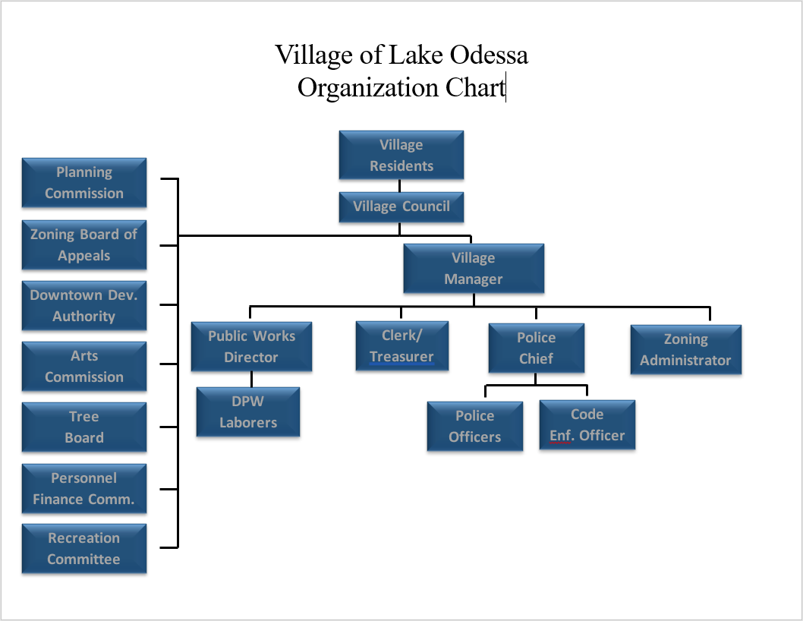





The Village President and Council are the legislative body for the community; its members are the community's decision makers. Power is centralized in the elected Council, which approves the budget, adopts all legislation, and establishes policies and procedures for the Village. The Council also focuses on the community's goals, major projects, and such long-term considerations as community growth, land use development, capital improvement plans, capital financing, and strategic planning.

VILLAGE COUNCIL

**Karen Banks**, President, *Term of Office: 2020-2024*  
Currently serving on: Personnel / Finance Committee, Planning Commission, Arts Commission, Downtown Development Authority

**Terri Cappon**, President Pro Tem, *Term of Office: 2022-2024*  
Currently serving on: Finance Committee and the Lakewood Recreational Authority

**Michael Brighton**, Council Trustee, *Term of Office: 2022-2026*  
Currently serving on: Personnel / Finance Committee, Website Committee

**Jennifer Hickey**, Council Trustee, *Term of Office: 2022-2026*

Currently serving on: Website Committee

**Carrie Johnson**, Council Trustee, *Term of Office: 2020-2024*  
Currently serving on: Recreational / Special Projects Committee, Arts Commission

**Robert Young**, Council Trustee, *Term of Office: 2020-2024*

Currently serving on: Recreational/ Special Projects Committee, Website Committee

**Martha Yoder**, *Council Trustee, Term of Office: 2022-2026*

*Currently serving on*: Finance Committee, Planning Commission, Lakewood Wastewater Authority



Village departments and trained staff are committed to the Village’s core values to guide growth, provide quality services, facilitate neighborhood sustainability and be good stewards of the public trust. Each staff member works together in a highly collaborative and cooperative environment to cultivate continual improvements and progress in the village.

VILLAGE STAFF

**Gregg Guetschow**, *Interim* *Village Manager*

**Kathy Forman***, Village Clerk/ Treasurer, Serving Lake Odessa since: 2021*

**Jesse Trout**, *Director of Public Works,* *Serving Lake Odessa since: 2017. Village Tree Board member, Streets Administrator*

**Kendra Backing**, *Police Chief,* *Serving Lake Odessa since: 2018*

**Scott Hubbert**, *Department of Public Works Laborer*, *Serving Lake Odessa since: 2016*

**James Wortley**, *Department of Public Works Laborer, Serving Lake Odessa since: 2016*

**Jacob Hanson***, Department of Public Works Laborer, Serving Lake Odessa since: 2016*

**Eric Tollefson***, Police Officer, Serving Lake Odessa since: 2019*

**Artemio “Art” Villanueva***, Code Enforcement Officer, Serving Lake Odessa since 2022*

**Jeanne Vandersloot**, *Zoning Administrator, Serving Lake Odessa since: 2004*



HISTORY

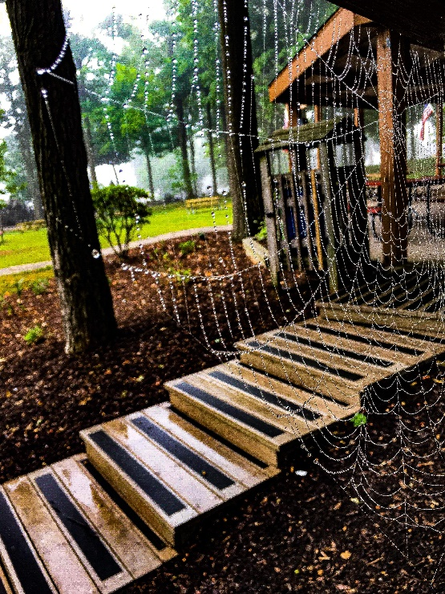The Village of Lake Odessa was incorporated in 1887 by Humphrey R. Wager, a capitalist from Ionia and Saranac, after buying an 80-acre farm through which the Detroit, Lansing & Northern Railway was to build a new track to Grand Ledge and Grand Rapids.  The original town, known as Bonanza, was settled slightly north of today's Lake Odessa --- and folded up and moved south when the first train came through in 1888.  
  
Prior to the construction of the new railroad tracks, what is now Lake Odessa was a broad expanse of fertile farm land, and the typical country cross-road was about a mile north of Jordan Lake.  Before the advent of the railway, no one had ever dreamed of Lake Odessa.  Bonanza was the big settlement in this area, and, for that time period, was a bustling industrial center.  It was a strange twist of fate and broadening civilization that in the space of a few years, practically a whole town moved and a corporate village was created in the midst of meadowlands, leaving the original settlement to revert to corn fields.  The principal merchants of Bonanza simply moved buildings, inventory and all, to the new location.  
  
Lake Odessa's name was derived from the two lakes, Tupper Lake and Jordan Lake, and the township within which the Village was incorporated, Odessa Township.  The Township was named by a committee in 1846, hoping to be somewhat exclusive while at the same time, honoring one of Russia's cities.  The committee, chaired by Elder Tupper, undoubtedly endorsed the suggestion of young Myron Tupper, who was a great reader of history and admired Russian lore.  
  
The main street, 4th Avenue, was constructed in 1887, and was nothing but a muddy lane until it was first paved in 1916.  The Lake Odessa Public School was built in 1888, put on an addition in 1896, and was demolished by fire in 1921, after which it was immediately rebuilt.  
  
The Village paid $1,000 for the park property on South Main Street in 1900.  The park remains today in its natural state, with more than two hundred towering maple, beech and oak trees.

In 1967, the Page Memorial Building was built as a village and township hall, with funds donated by the estate of a successful Lake Odessa businessman, millionaire Frank Page, who inherited the bulk of his fortune from a milk condensing process developed by his father.

Over the years, "Lake Odessians" have always been very proud of their beautiful park, and the public beach at Jordan Lake.  In 1991, over 400 volunteers worked feverishly for five days building the very popular Swifty's Place, in the park, a wooden playground superstructure constructed with enough lumber to build five homes.  In 2012, a $300,000 grant was obtained through the DNR and along with local matching funds, improvements were made to the public beach area that included a universally accessible floating dock, all terrain wheelchairs, a security system, canoe/kayak launch and parking lot lighting.



CAPITAL IMPROVEMENT PLAN

A capital improvement plan is a financial planning and management tool that lists proposed capital projects and capital purchases for the future. This multi-year document identifies and prioritizes the need for improvements and purchases and coordinates their funding and optimal time frames for completion. It is also a process that provides order and continuity to the repair, replacement, construction and/or expansion of the Village of Lake Odessa facilities. It puts focus on preserving infrastructure while ensuring the prudent and efficient use of public funds.

Capital improvement projects are major and infrequent expenditures, such as the construction of a new facility, a major rehabilitation or repair of an existing facility, or the purchase of major equipment or property. Capital improvement projects are non-recurring expenditures that tend to be large in cost and have a long-term usefulness.

The following plan sets forth the proposed expenditures for systematically constructing, maintaining, upgrading and replacing the community’s infrastructure. In order to be useful as a tool for budgeting and sound financial management, the plan must be updated annually by reviewing existing projects, proposing new projects and potentially extending projects. This process considers the short term and long-term impacts on the associated funds proposed for use.

It should be noted that any capital improvement plan is, like a budget, a fluid document that is used as a guidepost for a community – funding opportunities, through grants or other unknown or newly created revenue sources can impact the plan by making some listed projects a sudden priority. Conversely, equipment failures, emergencies, pandemics, revenue shortfalls, or a lack of grant funding can be a determining factor for a project not to be started, funded, or pursued, in any given year. Equipment breaks. Emergencies happen. While this plan gives the Village a firm direction, it is not set in stone and should not be considered a rigid certainty.

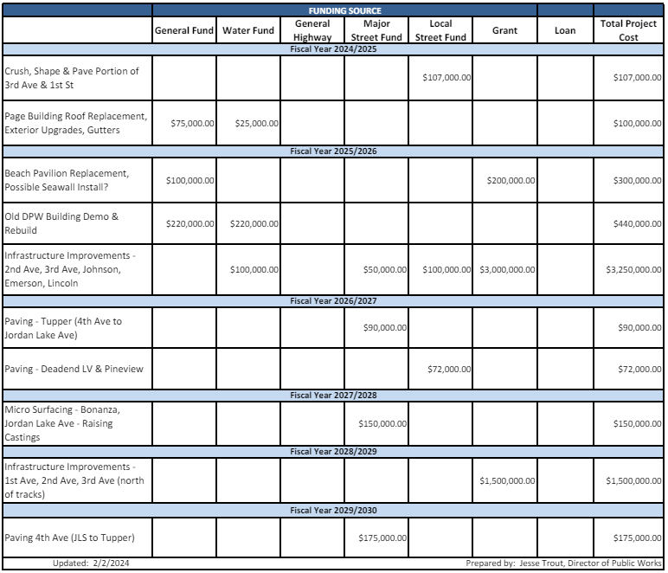



GENERAL FUND

**REVENUES**

The General Fund is the primary operating fund for the village. The General Fund derives its revenue from several sources, with the top two being property tax and state shared revenue. Other revenues include cable franchise fees, park and beach pavilion rental fees, metro act, trailer taxes and other miscellaneous fees.

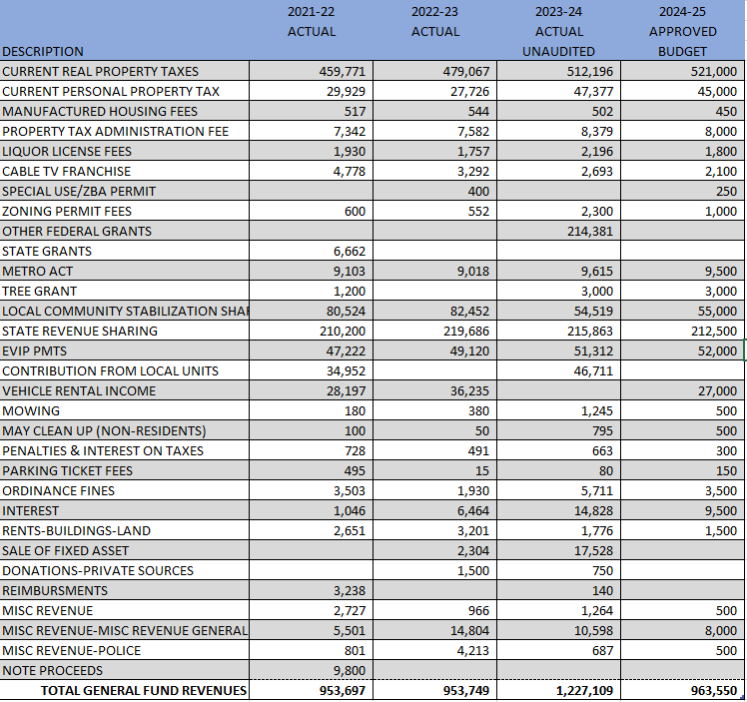

**APPROPRIATIONS**

**GENERAL FUND - GOVERNING BODY**

The General Government Department includes responsibilities of the elected officials, Clerk’s office and Treasurer’s office. This section includes contracted services for attorneys, legal publications, downtown development, office supplies and other miscellaneous government activities.

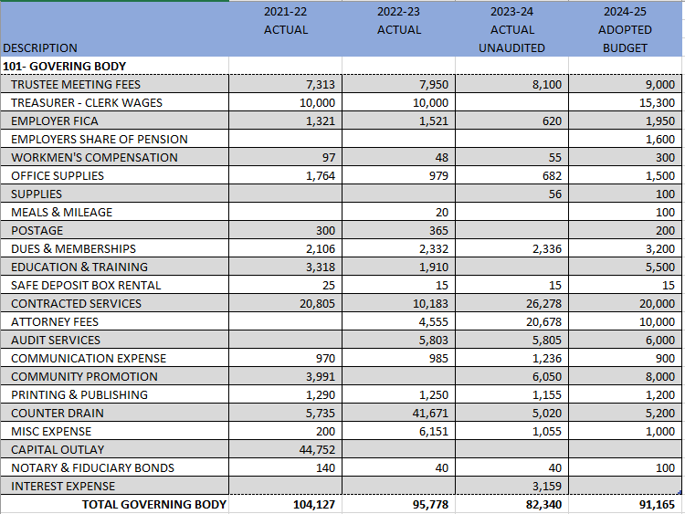

**GENERAL FUND - MANAGER’S DEPARTMENT**

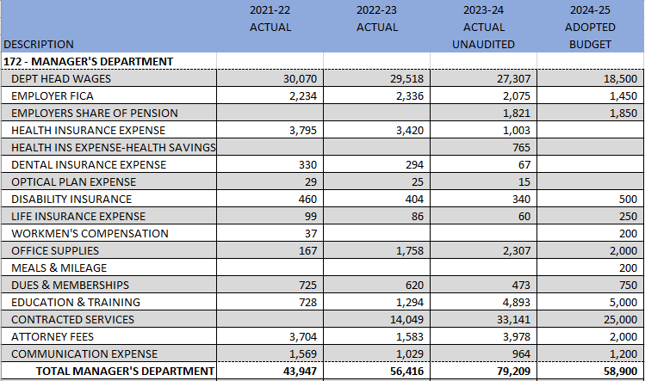

**GENERAL FUND - PAGE MEMORIAL BUILDING**

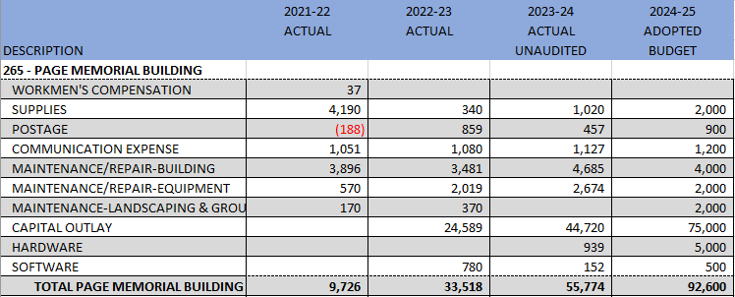



GENERAL FUND - POLICE DEPARTMENT

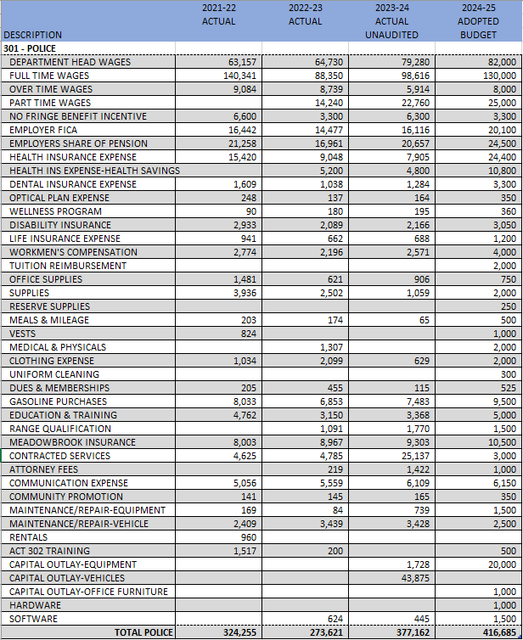



GENERAL FUND - DEPARTMENT OF PUBLIC WORKS

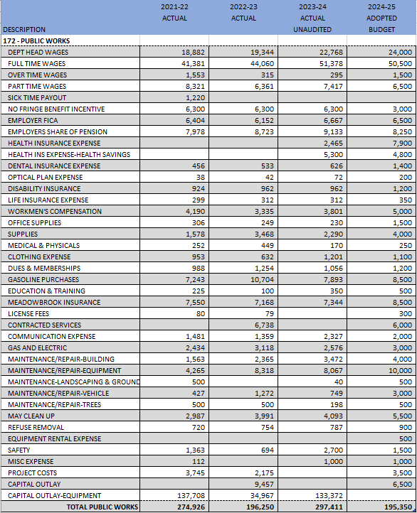

GENERAL FUND - PARKS AND RECREATION

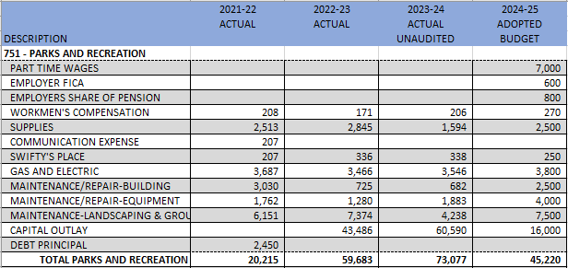

GENERAL FUND - UTILITIES, ZONING & ECONOMIC DEVELOPMENT

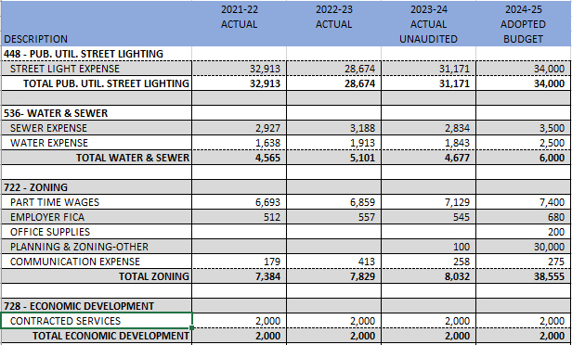



GENERAL FUND OVERVIEW

GENERAL FUND REVENUE AND EXPENSES

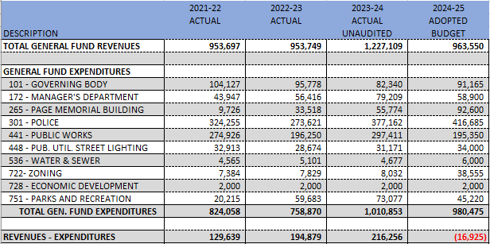



MAJOR STREET FUND

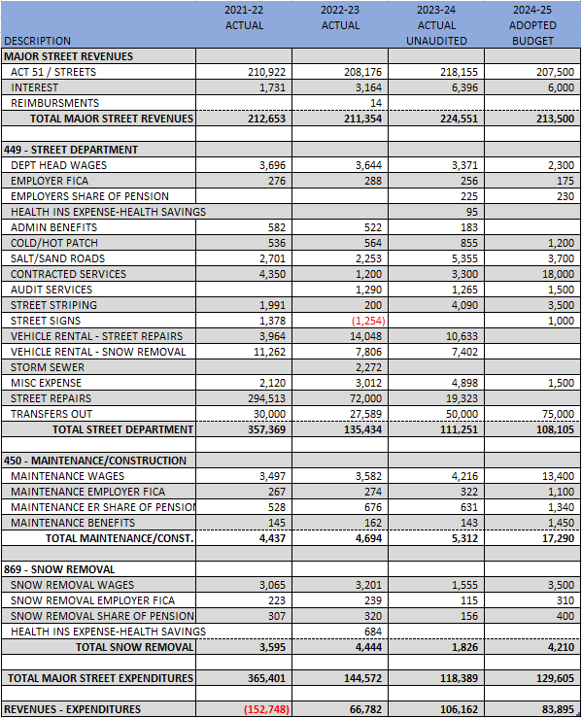

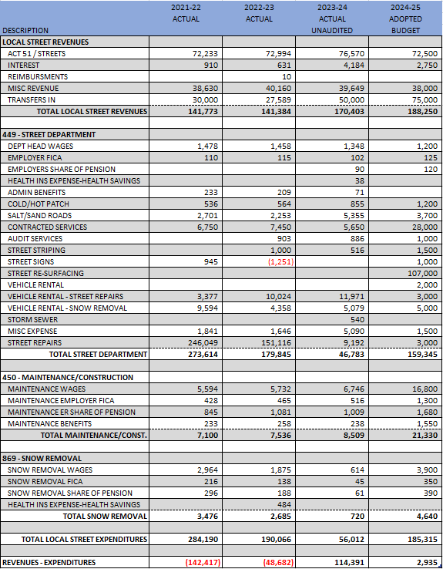

LOCAL STREET FUND



WATER FUND

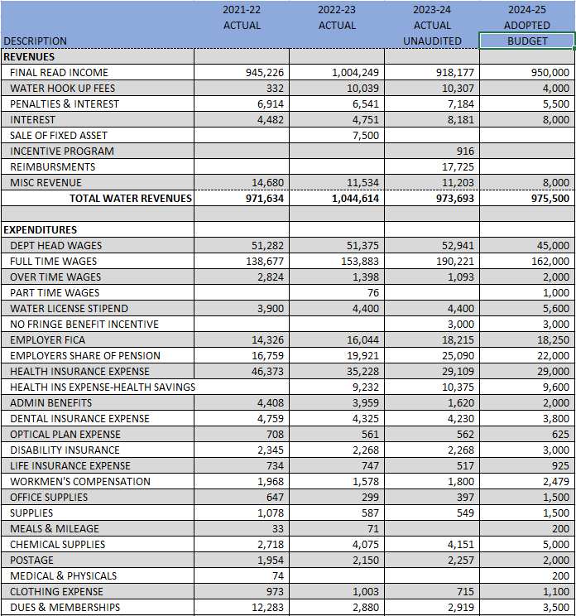

*(The Water Fund Budget is continued on the next page)*

WATER FUND CONT.

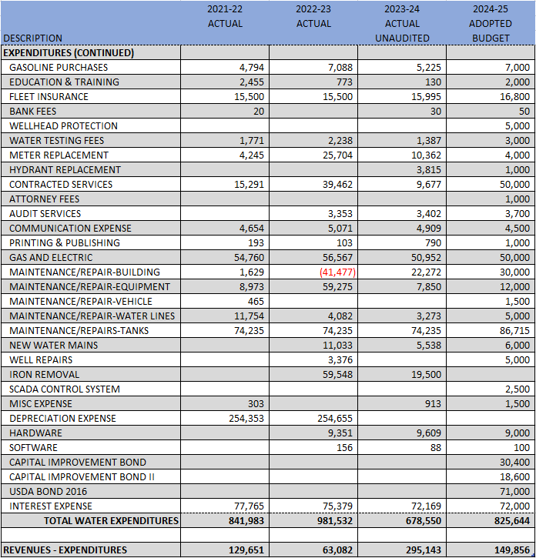



GENERAL HIGHWAY FUND

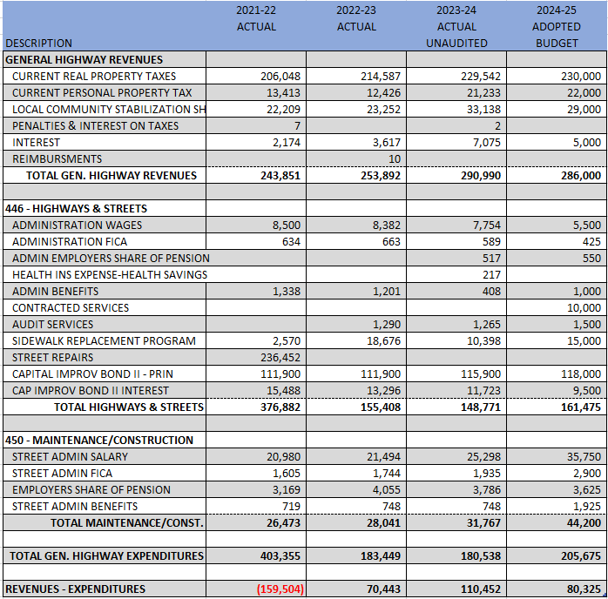



DOWNTOWN DEVELOPMENT AUTHORITY

Under the provisions of Act 197 of Public Acts of 1975 of the State of Michigan, as amended, the Downtown Development Authority was established in 2004, in the Village of Lake Odessa. The Act was developed to assist units of government in their encouragement of historic preservation and to encourage and promote economic development, growth and revitalization in central business districts of Michigan municipalities.

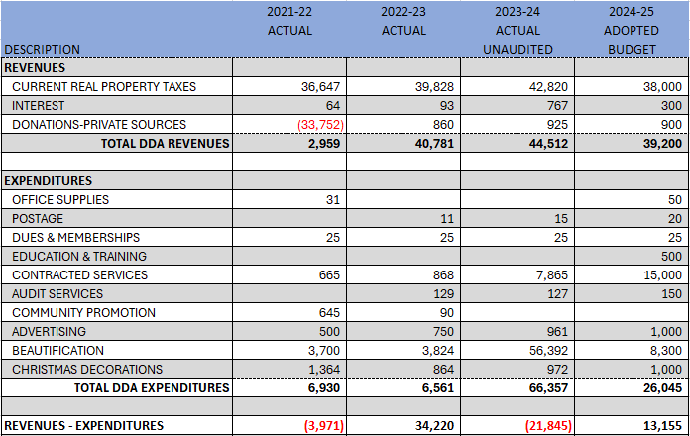

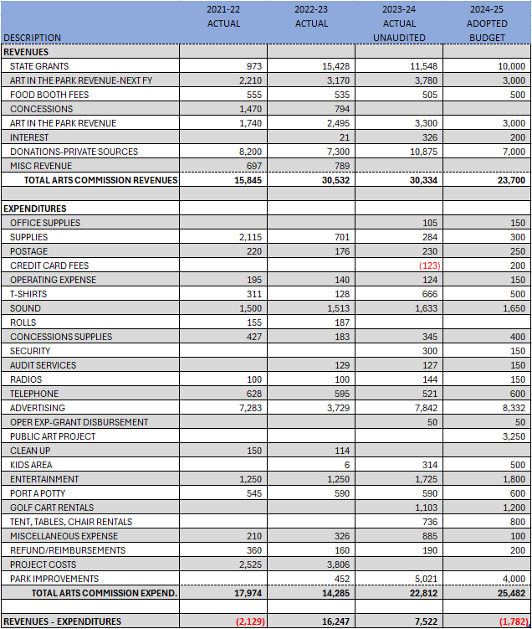

ARTS COMMISSION



SUPPLEMENTAL INFORMATION

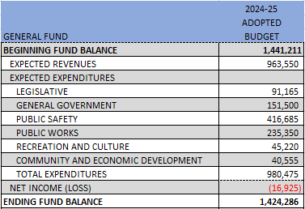



SUPPLEMENTAL INFORMATION



